Experiment No – 10
Title / Aim :- Load and display JSON data using fetch() and jQuery $.getJSON(); render results dynamically in a table.
Software/Tools Required :-
- Visual Studio Code (VS Code)
- Google Chrome / Any Web Browser
- HTML
- JavaScript
CODE :
Index.html
<!DOCTYPE html>
<html lang="en">
<head>
<meta charset="UTF-8">
<meta name="viewport" content="width=device-width, initial-scale=1.0">
<title>Campus Student Manager</title>
<link rel="stylesheet" href="style.css">
<!-- jQuery -->
<script src="https://code.jquery.com/jquery-3.7.1.min.js"></script>
</head>

<body>
<div class="container">
<header>
<h1>🎓 Campus Student Manager</h1>
<p>Student Information Dashboard</p>
</header>
<div class="add-box">
<h2>➕ Add New Student</h2>
<div class="form">
<input
type="text"
id="name"
placeholder="Student Name"
>
<input
type="text"
id="department"
placeholder="Department"
>
<select id="year">
<option value="">Select Year</option>
<option value="1st Year">1st Year</option>
<option value="2nd Year">2nd Year</option>
<option value="3rd Year">3rd Year</option>
<option value="4th Year">4th Year</option>
</select>
<input
type="number"
id="cgpa"
placeholder="CGPA"
step="0.1"
min="0"
max="10"
>
<button onclick="addStudent()">
Add Student
</button>
</div>
</div>
<div class="load-box">
<button onclick="loadUsingFetch()">
Load using fetch()
</button>
<button onclick="loadUsingJQuery()">
Load using $.getJSON()
</button>
</div>
<div class="table-box">
<div class="table-heading">
<h2>📋 Student List</h2>
<span id="studentCount">
Students: 0
</span>
</div>
<table>
<thead>
<tr>
<th>ID</th>
<th>Name</th>
<th>Department</th>
<th>Year</th>
<th>CGPA</th>
<th>Action</th>
</tr>
</thead>
<tbody id="studentTable">
</tbody>
</table>
</div>
</div>
<script src="script.js"></script>
</body>
</html>

Style.css
* {
margin: 0;
padding: 0;
box-sizing: border-box;
}
body {
font-family: Arial, sans-serif;
background: #F7F1DF;
color: #36332D;
}
.container {
width: 92%;
max-width: 1100px;
margin: 30px auto;
}
header {
background: #3D3A34;
color: #FFF8E7;
padding: 30px;
text-align: center;
border-radius: 16px 16px 0 0;
}
header h1 {
font-size: 30px;
margin-bottom: 8px;
}
header p {
color: #E9D98A;
}
.add-box {
background: #FFFDF5;
padding: 25px;
}
.add-box h2 {
color: #5A4B18;
margin-bottom: 18px;
}
.form {
display: grid;
grid-template-columns: 1fr 1fr;
gap: 12px;
}
input,
select {
padding: 13px;
border: 1px solid #D8C98A;
border-radius: 8px;
font-size: 14px;
outline: none;
background: #FFFEF9;
color: #36332D;
}
input:focus,
select:focus {
border-color: #C5A52E;
box-shadow: 0 0 0 2px #F2E8B9;
}
.form button {
padding: 13px;
border: none;
border-radius: 8px;
background: #C5A52E;
color: #2F2C25;
font-size: 15px;
cursor: pointer;
font-weight: bold;
}
.form button:hover {
background: #A98B1F;
color: white;
}
.load-box {
background: #F3E9C5;
padding: 18px;
text-align: center;
border-top: 1px solid #DDD09B;
border-bottom: 1px solid #DDD09B;
}
.load-box button {
padding: 11px 20px;
margin: 5px;
border: none;
border-radius: 8px;
background: #5A554B;
color: #FFF9E8;
cursor: pointer;
font-weight: bold;
}
.load-box button:hover {
background: #C5A52E;
color: #2F2C25;
}
.table-box {
background: #FFFDF5;
padding: 25px;
border-radius: 0 0 16px 16px;
}
.table-heading {
display: flex;
justify-content: space-between;
align-items: center;
margin-bottom: 18px;
}
.table-heading h2 {
color: #5A4B18;
}
#studentCount {
background: #EFE3A8;
color: #5A4B18;
padding: 8px 14px;
border-radius: 20px;
font-weight: bold;
}
table {
width: 100%;
border-collapse: collapse;
}
th {
background: #C5A52E;
color: #2F2C25;
padding: 14px;
text-align: left;
}
td {
padding: 13px;
border-bottom: 1px solid #E5DDBE;
}
tr:hover {
background: #F8F0D2;
}
.delete-btn {
background: #6B665C;
color: #FFFDF5;
border: none;
padding: 7px 12px;
border-radius: 6px;
cursor: pointer;
}
.delete-btn:hover {
background: #3D3A34;
}

Script.js
let students = [];
function loadUsingFetch() {
fetch("students.json")
.then(response => response.json())
.then(data => {
students = data;
displayStudents();
})
.catch(error => {
console.log("Error loading JSON:", error);
alert("Unable to load students.json");
});
}
function loadUsingJQuery() {
$.getJSON("students.json", function(data) {
students = data;
displayStudents();
}).fail(function() {
alert("Unable to load students.json");
});
}
function displayStudents() {
let table = "";
students.forEach(function(student) {
table += `
<tr>
<td>${student.id}</td>
<td>${student.name}</td>
<td>${student.department}</td>
<td>${student.year}</td>
<td>${student.cgpa}</td>
<td>
<button
class="delete-btn"
onclick="deleteStudent(${student.id})">
Delete
</button>
</td>
</tr>
`;
});
document.getElementById("studentTable").innerHTML = table;
document.getElementById("studentCount").innerText =
"Students: " + students.length;
}
function addStudent() {
let name =
document.getElementById("name").value.trim();
let department =
document.getElementById("department").value.trim();
let year =
document.getElementById("year").value;
let cgpa =
document.getElementById("cgpa").value;
if (name === "" ||
department === "" ||
year === "" ||
cgpa === "") {
alert("Please fill all fields.");
return;
}
let newStudent = {
id: students.length + 1,
name: name,
department: department,
year: year,
cgpa: parseFloat(cgpa)
};
students.push(newStudent);
displayStudents();
document.getElementById("name").value = "";
document.getElementById("department").value = "";
document.getElementById("year").value = "";
document.getElementById("cgpa").value = "";
}
function deleteStudent(id) {
students = students.filter(function(student) {
return student.id !== id;
});
displayStudents();
}

Students.json
[
{
"id": 1,
"name": "Shivangi Kushwaha",
"department": "Computer Science",
"year": "3rd Year",
"cgpa": 8.7
},
{
"id": 2,
"name": "Sanvi Wadhankar",
"department": "Information Technology",
"year": "2nd Year",
"cgpa": 9.1
},
{
"id": 3,
"name": "Anubha Sethi",
"department": "Electronics",
"year": "4th Year",
"cgpa": 8.3
},
{
"id": 4,
"name": "Shruti Bawankar",
"department": "Computer Science",
"year": "3rd Year",
"cgpa": 9.4
}
]

Output:
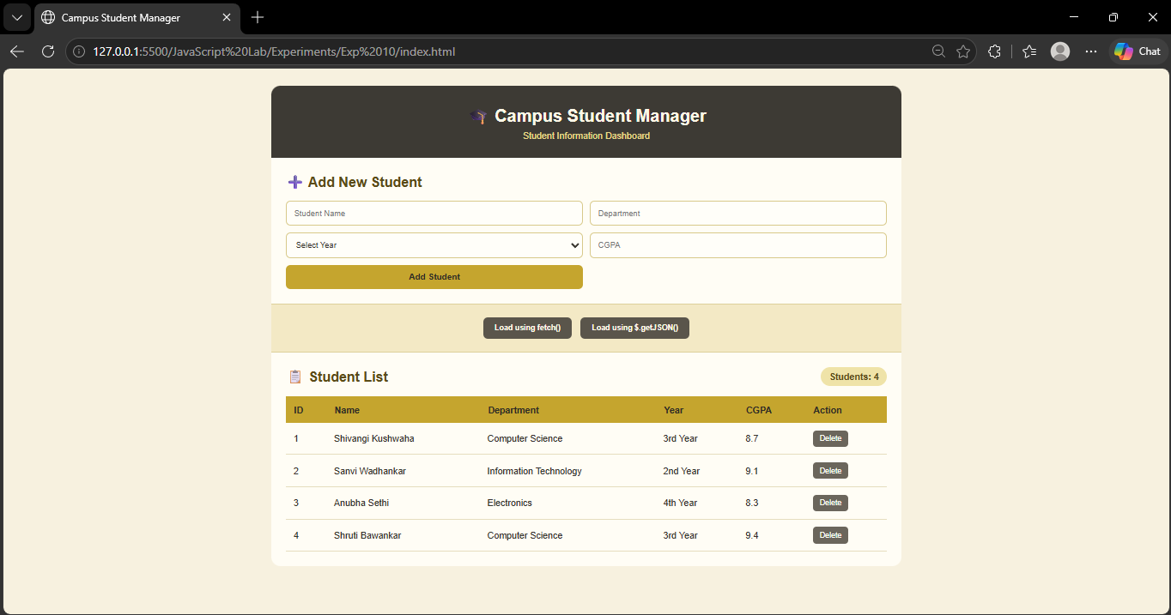

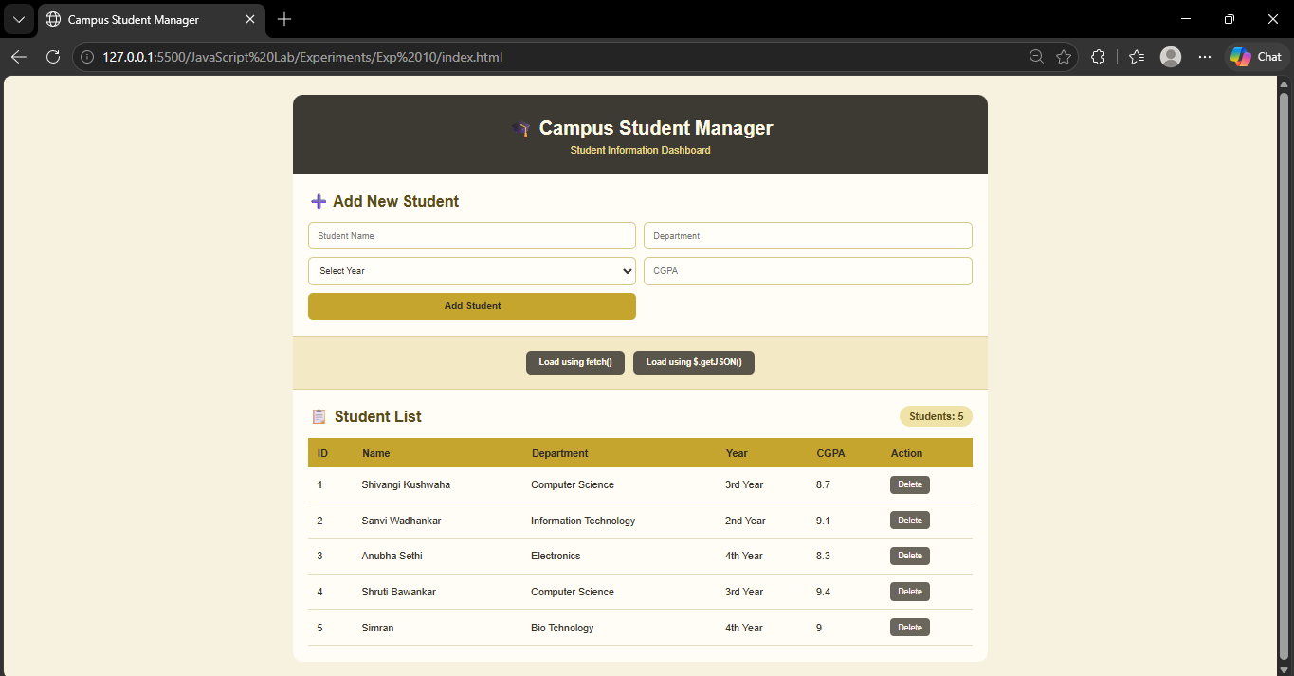

Result / Conclusion :-
Thus, JSON data was successfully loaded using both fetch() and jQuery $.getJSON(). The retrieved student information was dynamically displayed in an HTML table, and new student records could be added through the user interface. This practical demonstrates the use of JSON, asynchronous data fetching, jQuery, and dynamic DOM manipulation.

